Analysing the effect of the coin toss in Cricket

*Shane Butler – s00189384*

1. Introduction

Since its origin in the 17th century in England (ICC, 2021), cricket has grown to be one of the most played and popular sports in the world. Recently it has been listed as the 2nd most popular sport with 2-3 billion fans, the majority of which reside in the United Kingdom, Australasia, South Africa, and South Asia (Devano, 2021). More than 8000 games have been played professionally between countries and countless others played domestically by professionals and amateurs over history (Cricinfo, 2021).

A key moment to any cricket match happens before the game even begins. The captains of both teams take part in a coin toss (Figure 1) and the winner decides for their team if they will elect to bat or field first (MCC, 2021). Cricket is predominantly an outdoor sport played on grass and the conditions of the ground and weather play a vital role in the difficulty of batting for a team. It is easier for a batsman to effectively strike a ball and score runs for their team the less a ball moves through the air or changes direction after landing. Cloudy and more overcast weather will make a ball swing more in the air compared to clear weather, thus making it more difficult for a batsman to score runs for their team. Similarly, a more deteriorated pitch makes a spinning ball change direction more drastically after landing compared to a surface that is less deteriorated.

Figure 1 - Coin toss between England and Australia

A captain will assess these conditions at the coin toss to determine whether it is more advantageous to bowl or bat first. Other sports such as football may also have a coin toss to determine certain starting conditions before a game begins, however due to conditions playing a more important role in cricket compared to other sports, this can have a big effect on the outcome of a game and can give a team a big advantage. This essay will look at results from the various forms of cricket to assess how much of an impact winning or losing the toss has on a games result. This will also help to answer the question of whether the coin toss rule should be reworked to make it fairer on the team who loses the toss.

2. Dataset

In order to analyse data in relation to the coin toss in cricket, it was important to collect data that displayed the result of a game as well as the team who won the toss and their decision to bat or field first. The website “ESPN Cricinfo” has in depth statistics and records of professional games played both domestically and internationally, therefore it was a good resource to gather data for this essay. Data was scraped using a custom script in python which was reused to generate csv files for professional international matches in all three forms of cricket – test matches, one day internationals and T20 games. “ESPN Cricinfo” has webpages that contains links to results in a table format for each year since records began. Each row in these tables contains result information for each game, as well as a further link to more detailed information about the game such as the scorecard and more importantly the toss result.

Overall, python web scraping had to go through 3 webpages to generate rows of information for each game result. The columns in the dataset (Figure 2) contain the main information for each game such as the team names, the winner, how the result was achieved, the date and location the game took place and the team who won the toss and their decision to bat or field first. The data used for this analysis comprises of three tables of international results between teams in the three forms of cricket, which amounts to over 8000 rows of records.

Figure 2 - Head of results table for test match cricket

3. Exploratory Data Analysis

Data Clean-up

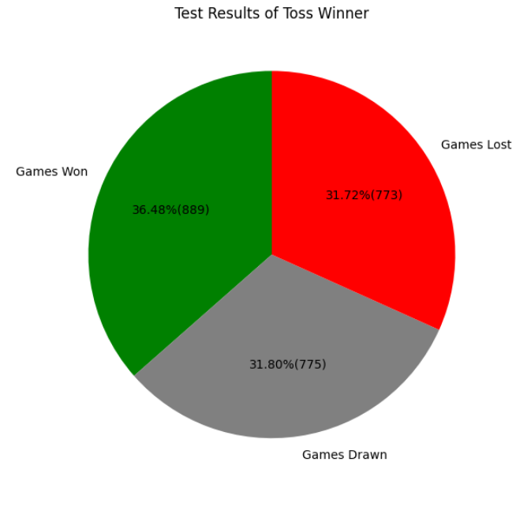The tables of results on “ESPN Cricinfo” did not have any null values or missing information, therefore making the clean-up of data easier. There were some instances where the scoreboard link for a game led to a webpage that did not work, thus meaning that obtaining coin toss information for that game was unattainable. In these instances, the data for “Toss Winner” and “Toss Decision” were set to empty. Due to the toss information being important for this analysis, any row in the table that did not have toss information was removed. A test match in cricket can go on for a maximum of five days, and certain games have started in one year and finished on the next. The python web scraping script checked the date value for any of these occurrences and modified the value so that the date would be set to the starting date of the game. If a test match did occur in this way over two separate years, “ESPN Cricinfo” would display the record for that game twice in two different year tables. These duplicate records were checked for and removed from the tables. Certain match results also were not reached due to the game being abandoned and these rows were also removed regardless of them containing toss information. Certain rows in the column also contained names of countries that were shortened or abbreviated. Any instances of this were replaced by the regular name of the country in order to ensure that each country was represented by the same exact text.

EDA Results

Once issues with the data were cleaned up, various graphs and information were gathered for each form of cricket. The information that was the most valuable for the purpose of this essay was how teams fared in relation to winning or losing the toss and which toss decision was the most popular. As shown in (Figure 3), winning the toss had the most impact in test match cricket, with teams having a 5% higher win rate winning the toss compared to losing. Chart, bar chart, waterfall chart
Winning the toss had much of a lower impact in one day cricket, with ODI and T20 games each having a close to 50% split between either winning or losing. There was also a similarly even split between teams’ toss decisions in one day cricket, with no predominant choice emerging for shorter forms of the game. T20 cricket had just a 3-game difference between batting or fielding first from more than 1,400 games. Batting first was a much more popular choice in test matches, with over 70% of teams electing to bat first (Figure 4). One of the reasons that explains this strong preference to bat first in test matches is the much longer potential game length of 5 days compared to a game that lasts just one day. Cricket pitches are known to heavily deteriorate the longer a game progresses, therefore making batting on the later days of a test match more difficult due to a rougher surface making the ball behave a lot more unpredictably (Cricketers Hub, 2021). Captains therefore seem to favour batting first in order to avoid this issue as long as conditions on day one of a test match do not heavily favour Chart, histogram
bowling.

Figure - Toss Winner Test Records

Figure - Test Match Toss Decisions

The success of the team winning the toss was also explored throughout each year. The win percentage of these teams seem to heavily fluctuate early in test history mainly due to the low amounts of games played each year and the fact that test games only involved England, Australia, and South Africa for the first 41 years. One day formats also experienced similarly strong fluctuations the first years of their inception due to similar reasons. One day test win percentages also were consistently in the range of 40-60%, whereas test match win percentages fell to under 25% quite frequently. The main reason for this lower win percentage of the toss winner in test matches is due to the result of a draw being very common in test matches at 31.8% (Figure 3). Another factor is that due to the longer format of 5 days and 2 innings per team, there is more opportunities for a game to swing either way and the advantage of winning the toss could be lower compared to one day games.

Figure - Test Match Win Percentage Each Year

Line graphs were also created to compare the amounts of bat and field first decisions made throughout history. For every year in test match cricket the number of decisions to bat first were greater than the number of decisions to field first. This shows that the issue of batting becoming more difficult the longer a game progresses has been consistent throughout history and not a recent occurrence. Fielding first was the more common decision early in ODI history (Figure 6), with batting first becoming the more predominant choice from the mid 90’s onwards. This could be coincidence or due to the fact that teams have adopted different strategies as international one day cricket evolved, and higher scoring games became more frequent (Cox, 2021).

Figure - ODI Toss Decisions Each Year

4. Questions

The exploratory data analysis and graphs produced provides a more detailed picture of international cricket results and their relationship to the coin toss. There are still further questions that can be answered relating to this topic:

1. Is there a big difference in the percentage of teams that went on to win the game after winning the toss in One Day International matches compared to T20 matches?
2. Is there a big difference in the percentage of teams that went on to win the game after winning the toss in one day cricket compared to test match cricket?
3. Is there a substantial difference between the percentage of games won or not won by the coin toss winner across all formats of international games?

5. Analysis Results

Question 1

Each unique year was calculated from the data for both One Day Internationals and T20 games and was used to generate a list containing the win percentage amount for each year. The lists of win percentage values of the toss winner were used in a two-sample independent test to see if the means of each list were equal. Since the p-value obtained was greater than the significance level, there was not enough evidence to suggest that the average win percentage of the toss winner between ODI and T20 cricket is significantly different.

Question 2

The lists of percentage values of toss winners that won the game for both one day formats were added together and compared with a similar list for test match cricket. The p-value obtained was less than the significance level which suggests that there are significant differences in the mean values of win percentages of the toss winner between one day and test cricket.

Question 3

Two lists were created each containing percentage of games won by the toss winners and the percentage of games not won for every year of each game format. These lists were then used in t-tests to generate p-values for the three different formats of cricket. In both one-day formats, the p-value was greater than the significance level which suggests that there is not a significant difference in the mean values of games either won or lost / tied. Test cricket did have p-values lower than the significance level, suggesting that there is a substantial difference between the two samples.

6. Conclusion

The coin toss is an integral part of cricket and determines the order of innings for each team. This analysis has looked at all international results for all formats of cricket to determine the effect of winning the toss on a team’s success and failure. For longer formats of the game, the coin toss was deemed to be more important to win as there was a bigger difference between the win and loss percentages for the toss winner in test matches compared to one day formats, although this difference was still relatively small. For One Day International and T20 cricket, the importance of winning the toss was less and did not seem to provide a significant effect on results. The evidence overall suggests that winning the coin toss in cricket hasn’t provided a substantial advantage to teams throughout history.

7. References

Icc-cricket.com. 2021. *International Cricket Council*. [online] Available at: <https://www.icc-cricket.com/about/cricket/history-of-cricket/early-cricket> [Accessed 13 December 2021].

Devano, S., 2021. *Top 10 Most Popular Sports In The World | 2022 Power Ranking*. [online] SportsBrowser. Available at: <https://sportsbrowser.net/most-popular-sports/> [Accessed 13 December 2021].

Cricinfo. 2021. *Complete cricket records and statistics for all cricket matches and players*. [online] Available at: <https://stats.espncricinfo.com/ci/engine/records/index.html> [Accessed 14 December 2021].

Lords.org. 2021. *Innings Law | MCC*. [online] Available at: <https://www.lords.org/mcc/the-laws-of-cricket/innings> [Accessed 14 December 2021].

Cricketers Hub. 2021. *Why Is Test Cricket So Difficult? – Full Explanation! | Cricketers Hub*. [online] Available at: <https://cricketershub.com/why-is-test-cricket-so-difficult-full-explanation/> [Accessed 15 December 2021].

Cox, D., 2021. *10 ways ODI cricket has changed in last two decades*. [online] Aljazeera.com. Available at: <https://www.aljazeera.com/sports/2019/6/3/10-ways-odi-cricket-has-changed-in-last-two-decades> [Accessed 18 December 2021].